**CONTENTS**

**CONTENTS**

|  |  |  |
| --- | --- | --- |
| **S.NO** | **TOPIC** | **PAGENO** |
| 1 | AIM | 1 |
| 2 | INTRODUCTION TO PYTHON | 3 |
| 3 | INTRODUCTION TO PROJECT | 5 |
| 4 | REQUIREMENTS | 6 |
| 5 | PROJECT ANALYSIS | 7 |
| 6 | CODING | 13 |
| 7 | OUTPUT | 19 |
| 8 | SUGGESTED IMPROVEMENTS | 20 |
| 9 | BIBLIOGRAPHY | 21 |

**AIM**

**AIM**

The main aim of this Project Petrol Pump Management System is to manage the details of stocks, fuels, prices, sales. The project deals with the development of the web based system for maintaining the regular records. The project is totally built at administrative end and thus only the administrator is guaranteed the access.

The purpose of the project is to build an application program to reduce the manual work for managing the details of stocks, fuels, prices, sales. It tracks all the details about the fuels, inventory, sales. This system also manage staff management like all information about the staff like ID, age, address, phone number.

1

**INTRODUCTION TO PYTHON**

**INTRODUCTION TO PYTHON**

Python is a widely used general-purpose, high level programming language. It was initially designed by **Guido van Rossum** in **1991** and developed by **Python Software Foundation**. It was mainly developed for emphasis on code readability, and its syntax allows programmers to express concepts in fewer lines of code. It is used for

* Web development (server-side),
* Software development,
* Mathematics,
* System scripting.

**BENEFITS OF PYTHON:**

* Python can be used on a server to create web applications.
* Python can be used alongside software to create workflows.
* Python can connect to database systems. It can also read and modify files.
* Python can be used to handle big data and perform complex mathematics.
* Python can be used for rapid prototyping, or for production-ready software development.
* Python works on different platforms (Windows, Mac, Linux, Raspberry Pi, etc).
* Python has a simple syntax similar to the English language.
* Python has syntax that allows developers to write programs with fewer lines than some other programming languages.
* Python runs on an interpreter system, meaning that code can be executed as soon as it is written. This means that prototyping can be very quick.

2

* Python can be treated in a procedural way, an object-orientated way or a functional way.
* The most recent major version of Python is Python 3, which we shall be using in this tutorial. However, Python 2, although not being updated with anything other than security updates, is still quite popular.
* In this tutorial Python will be written in a text editor. It is possible to write Python in an Integrated Development Environment, such as Thonny, Pycharm, Netbeans or Eclipse which are particularly useful when managing larger collections of Python files.
* Python was designed for readability, and has some similarities to the English language with influence from mathematics.
* Python uses new lines to complete a command, as opposed to other programming languages which often use semicolons or parentheses.
* Python relies on indentation, using whitespace, to define scope; such as the scope of loops, functions and classes. Other programming languages often use curly-brackets for this purpose.

3

**INTRODUCTION TO THE PROJECT**

**INTRODUCTION TO THE PROJECT**

**INTRODUCTION**

The “Petrol Pump Management System” has been developed to override the problems prevailing in the practice manual system .This software is supported to eliminate and in some cases reduce hardship faced by this existing system. Moreover this system is designed for the particular need of company to carry out operations in a smooth and effective manner.

Every organization, whether big or small, has challenges to overcome and managing the information to stocks, fuels, inventory. Every Petrol Pump Management System has different fuels needs, therefore we design exclusive employee managements systems that are adapted to managerial requirements. This is designed to assist in strategic planning, and will help you ensure that your organization is equipped with the right level of information and details for your future goals. Also, for those busy executive who are always on the go, our system come with remote access features, which will allow you to manage your workforce anytime, at all times. These system will ultimately allow you to better manage resources.

4

**OBJECTIVES OF THE PROJECT**

* Provides the searching facilities based on various factors. Such as fuels, sales, price, employee details.
* It tracks all information of stocks, inventory.
* To increase efficiency of managing the fuels, sales.
* It reduces the manual work.
* Provides better utilization of resources.

5

**REQUIREMENTS**

**REQUIREMENTS**

**HARDWARE REQUIRED:**

* Processor : PENTIUM(ANY)
* RAM : 512MB+
* Hard disk : SATA 40 GB OR ABOVE
* MOTHERBOARD : 1.845 OR 915,995 FOR PENTIUM 0R MSI

K9MM-V VIA K8M800+8237R PLUS

* CD/DVD r/w multi drive combo: (If back up required)
* FLOPPY DRIVE 1.44 MB : (If Backup required)
* MONITOR 14.1 or 15 -17 inch
* Key board and mouse
* Printer : (if print is required – [Hard copy])

**SOFTWARE REQUIRED:**

* Operating system : WINDOWS 7 AND ABOVE
* Python

**6**

**PROJECT ANALYSIS**

**PROJECT ANALYSIS**

* We have used the function **list.**
* The following lists are used:
* empid
* empname
* empage
* empaddr
* empphno
* vno
* par
* vol
* amt
* dte

7

**CODINGS**

**CODINGS**

#creating variables:

import datetime

print("____________________________________________________________________________")

print("")

print("\t $$$$ PETROL BUNK MANAGEMENT SYSTEM $$$$")

pet=1000

die=1000

petpri=100.0

diepri=100.0

empid=["1001","1002","1003"]

empname=["DHONI","ROHIT","KL.RAHUL"]

empage=["32","28","30"]

empaddr=["Chennai","Mumbai","Punjab"]

empphno=["9908789652","8974524367","8897436280"]

vno=["TN 33 AA 1020","TN 33 BB 2030","TN 33 CC 3040"]

par=["PETROL","DIESEL","PETROL"]

vol=["4","10","6"]

amt=["400.0","1000.0","600.0"]

dte=["November 12, 2019","November 12, 2019","November 12, 2019"]

while(1):

#program:

print(" ~~~~~~~~~~ Welcome to the MSD's Petrol Bunk ~~~~~~~~~~")

print("____________________________________________________________________________")

print("\n")

print("\t\t\t ----------------------------------")

print("\t\t\t| 1 | View Stocks |")

print("\t\t\t ----------------------------------")

print("\t\t\t| 2 | View Prices |")

print("\t\t\t ----------------------------------")

print("\t\t\t| 3 | View Sales |")

print("\t\t\t ----------------------------------")

print("\t\t\t| 4 | Update Petrol Price |")

print("\t\t\t ----------------------------------")

print("\t\t\t| 5 | Update Diesel Price |")

print("\t\t\t ----------------------------------")

print("\t\t\t| 6 | Petrol Purchase |")

print("\t\t\t ----------------------------------")

print("\t\t\t| 7 | Diesel Purchase |")

print("\t\t\t ----------------------------------")

print("\t\t\t| 8 | Bill Entry |")

print("\t\t\t ----------------------------------")

print("\t\t\t| 9 | Add New Employee |")

print("\t\t\t ----------------------------------")

print("\t\t\t| 10 | View Employee Details |")

print("\t\t\t ----------------------------------")

print("\t\t\t| 11 | Delete Employee |")

print("\t\t\t ----------------------------------")

print("\t\t\t| 0 | Exit |")

print("\n")

try:

a=int(input("Select a choice : "))

print("____________________________________________________________________________\n")

if a == 0:

print("Thank you for using MSD's Petrol bunk")

print("************* Visit Again **************")

break

if a==1:

print("~~~~~~~~~~~~~~~~~~~~~~~~~~~ VIEW STOCKS ~~~~~~~~~~~~~~~~~~~~~~~~~~~")

print("PETROL = "+str(pet)+" ltr")

print("DIESEL = "+str(die)+" ltr")

print("-------------------------------------------------------")

if a==2:

print("~~~~~~~~~~~~~~~~~~~~~~~~~~ VIEW PRICES ~~~~~~~~~~~~~~~~~~~~~~~~~~")

print("PETROL = Rs. "+str(petpri))

print("DIESEL = Rs. "+str(diepri))

print("-------------------------------------------------------")

if a==3:

print("~~~~~~~~~~~~~~~~~~~~~~~~~~~ VIEW SALES~~~~~~~~~~~~~~~~~~~~~~~~~~~")

f2=len(vno)

for i in range(f2):

y2=i+1

y1=str(y2)

print("S.NO = "+y1)

print("VEHICLE NO = "+vno[i])

print("PARTICULAR = "+par[i])

print("VOLUME = "+vol[i]+" ltr")

print("AMOUNT = Rs. "+amt[i])

print("DATE = "+dte[i])

print("************************************************")

if a==4:

print("~~~~~~~~~~~~~~~~~~~~~~~~ UPDATE PETROL PRICE~~~~~~~~~~~~~~~~~~~~~~~~")

petpri=float(input("ENTER PETROL PRICE : "))

if a==5:

print("~~~~~~~~~~~~~~~~~~UPDATE DIESEL PRICE~~~~~~~~~~~~~~~~~~~~~~~~~~~~~~~")

diepri=float(input("ENTER DIESEL PRICE : "))

if a==6:

print("~~~~~~~~~~~~~~~~~~~~~~~~~~~ PETROL PURCHASE ~~~~~~~~~~~~~~~~~~~~~~~~~~~")

pet=pet+(int(input("ENTER THE VOLUME OF PETROL : ")))

if a==7:

print("~~~~~~~~~~~~~~~~~~~~~~~~~~~DIESEL PURCHASE ~~~~~~~~~~~~~~~~~~~~~~~~~~~")

die=die+(int(input("ENTER THE VOLUME OF DIESEL : ")))

if a==8:

print("~~~~~~~~~~~~~~~~~~~~~~~~~~~ BILL ENTRY ~~~~~~~~~~~~~~~~~~~~~~~~~~~")

vno.append((input("Enter The VEHICLE NUMBER : ")))

print("CHOOSE THE PARTICULAR :")

print("Enter 1 FOR PETROL")

print("Enter 2 FOR DIESEL")

ch=int(input("Choose Any One : "))

if(ch == 1):

par.append("PETROL")

p1=int(input("Enter the Petrol Volume : "))

a1=p1*petpri

print("Price : "+str(a1))

pet=pet-p1

vol.append(""+str(p1))

amt.append(""+str(a1))

dat=datetime.date.today().strftime("%B %d, %Y")

dte.append(dat)

if(ch == 2):

par.append("DIESEL")

p1=int(input("Enter the Diesel Volume : "))

a1=p1*diepri

print("Price : "+str(a1))

die=die-p1

vol.append(""+str(p1))

amt.append(""+str(a1))

dat=datetime.date.today().strftime("%B %d, %Y")

dte.append(dat)

if a==9:

print("~~~~~~~~~~~~~~~~~~~~~~~~~~ ADD NEW EMPLOYEE ~~~~~~~~~~~~~~~~~~~~~~~~~~")

empid.append(input("Enter The Employee ID : "))

empname.append(input("Enter The Employee Name : "))

empage.append(input("Enter The Employee Age : "))

empaddr.append(input("Enter The Employee Address : "))

empphno.append(input("Enter The Employee Phone Number : "))

if a==10:

print("~~~~~~~~~~~~~~~~~~~~~~~~ VIEW EMPLOYEE DETAILS ~~~~~~~~~~~~~~~~~~~~~~~~”)

f2=len(empid)

for i in range(f2):

y2=i+1

y1=str(y2)

print("EMPLOYEE ID = "+empid[i])

print("EMPLOYEE NAME = "+empname[i])

print("EMPLOYEE AGE = "+empage[i])

print("EMPLOYEE ADDRESS = "+empaddr[i])

print("EMPLOYEE PHONE NUMBER = "+empphno[i])

print("************************************************")

if a==11:

print("~~~~~~~~~~~~~~~~~~~~~~~~~~ REMOVE STUDENT ~~~~~~~~~~~~~~~~~~~~~~~~~~")

f2=len(empname)

for y in range(f2):

y2=y+1

y1=str(y2)

print(y1+"EMPLOYEE NAME : ->> "+empname[y])

print("")

r1 = int(input("Select a employee name [ 0 for back ] : "))

if(r1 != 0):

temp=""+empname[r1-1]

empid.pop(r1-1)

empname.pop(r1-1)

empage.pop(r1-1)

empaddr.pop(r1-1)

empphno.pop(r1-1)

print(""+temp+" Removed Successfully!..")

if a>11:

print("Please enter a valid choice from 1-10 and 0")

except ValueError:

print("Please input as suggested.")

r=int(input("do you want to conti 1 or 0:"))

if r==1:

continue

else:

break

**OUTPUT**

**OUTPUT**

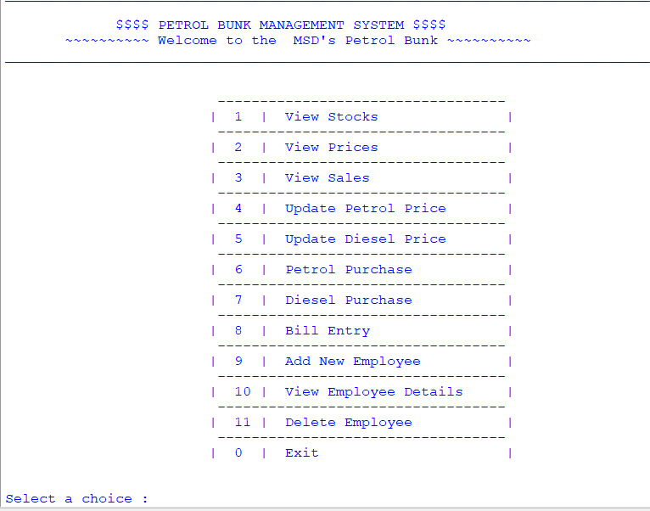

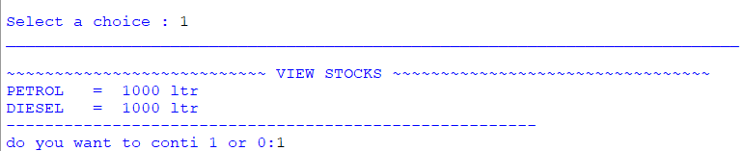

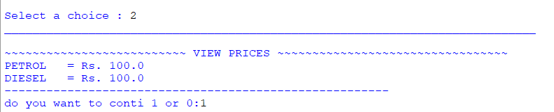

14

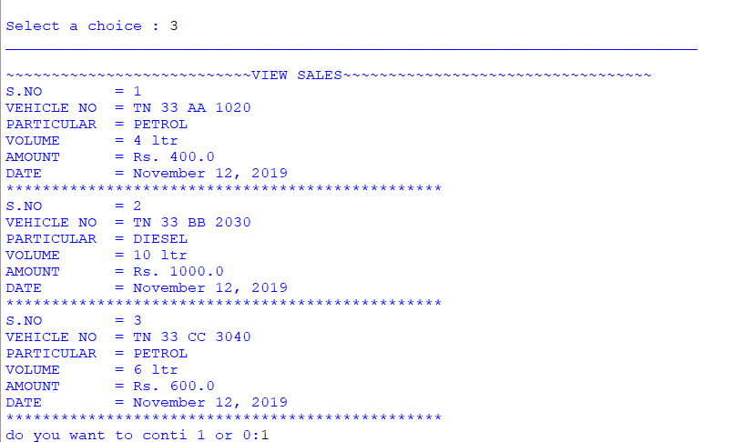

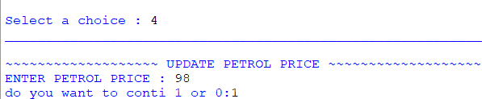

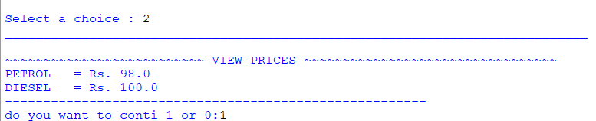

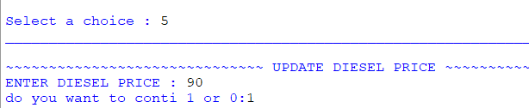

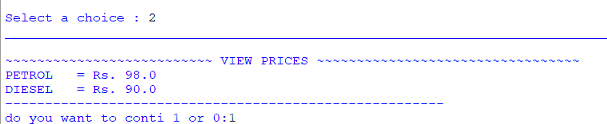

15

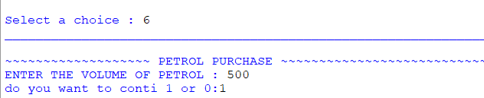

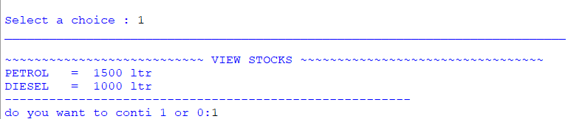

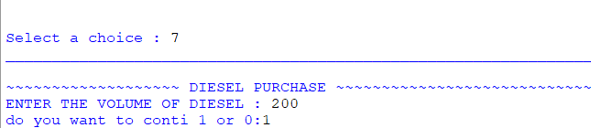

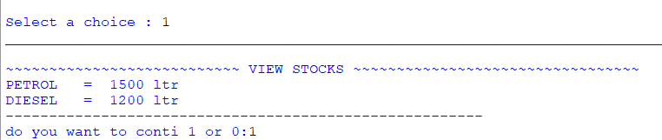

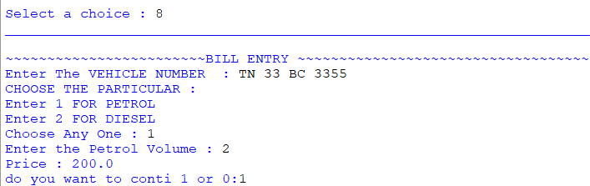

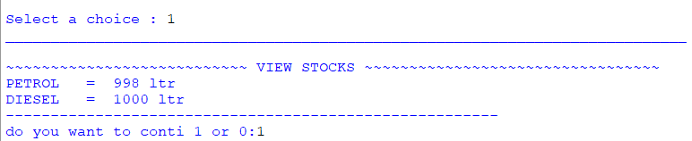

16

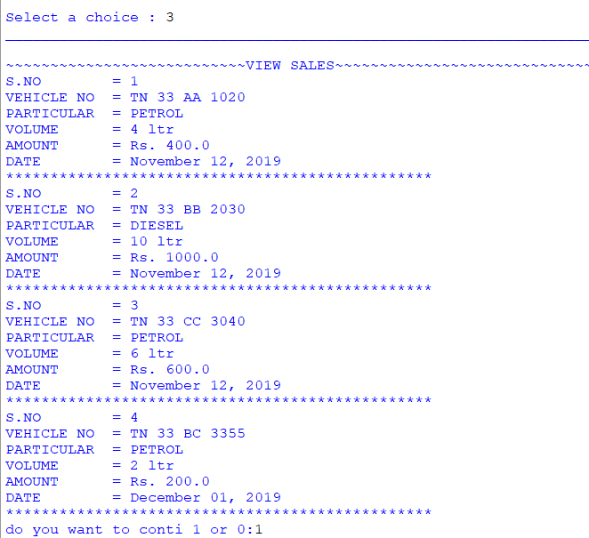

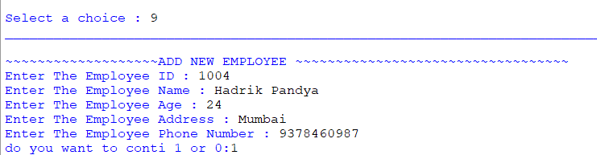

17

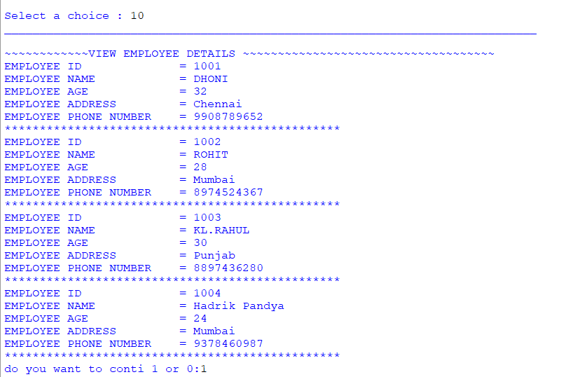

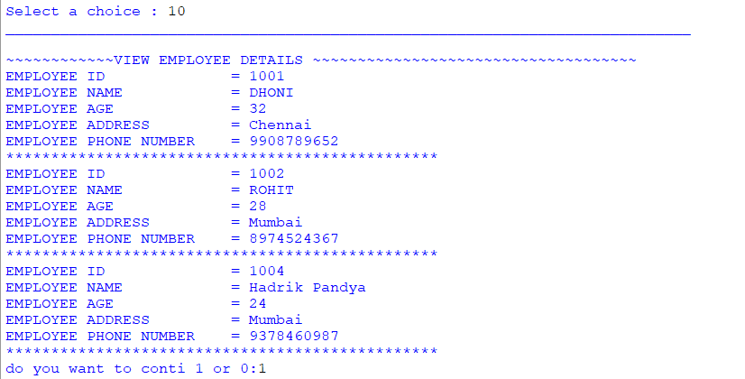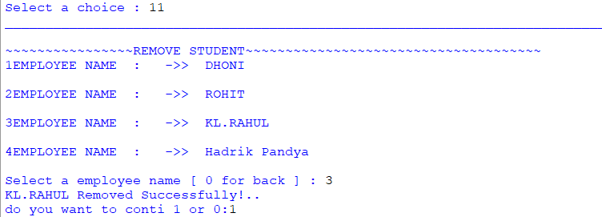

18

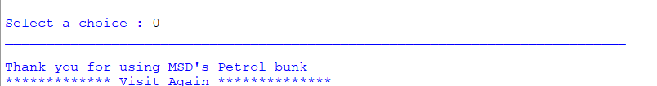

19

**SUGGESTED IMPROVEMENTS**

**SUGGESTED IMPROVEMENT**

* We can add printer in future.
* We can more advanced software for Petrol Pump Management System including more facilities.
* We can host the platform on online servers to make it accessible worldwide.
* We can store the data in database.
* Implement the backup mechanism for taking backup of database on regular basis.

20

**BIBLIOGRAPHY**

**BIBLIOGRAPHY**

**BOOKS REFERRED:**

Computer science With Python - Class XI By : Sumita Arora

**WEB SITES REFERED:**

Website: <https://www.w3resource.com>

https://en.wikipedia.org/wiki/E_(mathematical_constant)

21